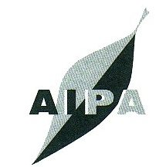

The Australian Institute of Polish Affairs

ANNUAL GENERAL MEETING

to be held on 19th October 2022

Proxy Form

AIPA Secretary,

I / We

_________________________________________________________

of _______________________________________________________

being financial member(s) of the Australian Institute of Polish Affairs Inc., hereby appoint

or failing him/her/them, the Chairman of the meeting, as my proxy to vote on my behalf at the Annual General Meeting of the Institute to be held on 19th October 2022 at 5.30 pm

Signature of Member________________________________________

